Blog Overview Component

**Page Reference** - <https://www.ancestry.com/corporate/blog/ancestryvolunteers-ancestry-2022-global-week-service>

**AEM URL** - <https://author-ancestry-dev2.adobecqms.net/content/ancestry-corp/us/en/blog/ancestryvolunteers-ancestry-2022-global-week-service.html?wcmmode=disabled>

We can use this component for showing the blog overview data.

For e.g. Text, images, videos, button

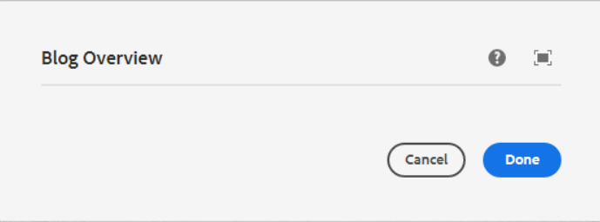

Once we add a blog overview component, it automatically shows one container inside that to add or drag any component to design the blog overview section.

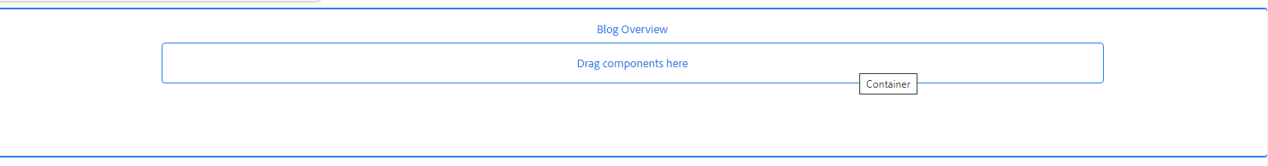

**Overview page Screenshot**

